Q.4 What is DFD? Create a DFD diagram on flipkart.

Data Flow Diagram (DFD) represents the flow of data within information systems. Data Flow Diagrams (DFD) provide a graphical representation of the data flow of a system that can be understood by both technical and non-technical users. The models enable software engineers, customers, and users to work together effectively during the analysis and specification of requirements.

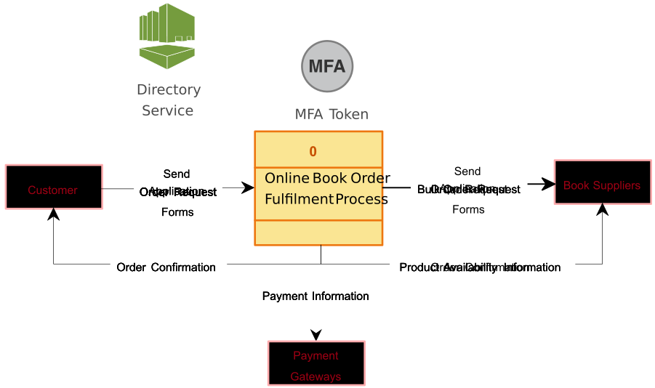

Q.5 What is a flowchart? Create a flowchart to make addition of two numbers.

Flowchart is a graphical representation of an algorithm. Programmers often use it as a program-planning tool to solve a problem. It makes use of symbols which are connected among them to indicate the flow of information and processing.

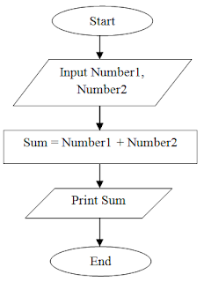

Q.6 What is Use Case Diagram? Create a use-case on bill payment on Paytm.

A Use Case Diagram is a vital tool in system design, it provides a visual representation of how users interact with a system. It serves as a blueprint for understanding the functional requirements of a system from a user’s perspective, aiding in the communication between stakeholders and guiding the development process.

